Nepal Sponsor Trip
November 1 - 17, 2024
(updated as of January 1, 2024)

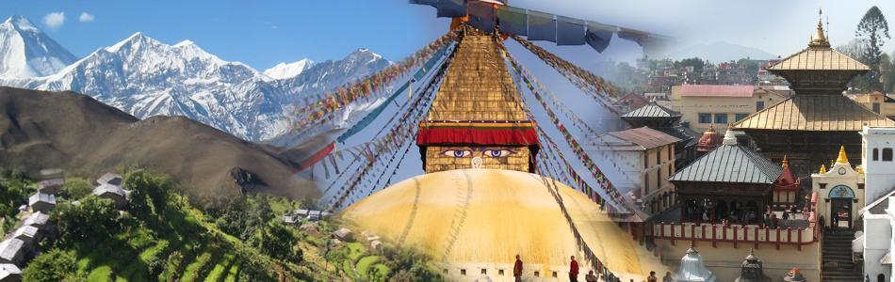

Trip-in-Brief: Kathmandu cultural tours, activities of Mitrata-Nepal Foundation for Children, and an excursion trip to resort town Pokhara for a view of Annapurna Himalayan range and mountain villages – including a two days of hiking option.

Day  Fri  Sat | Date  Nov 1-2 | ITINERARY – OUTLINE  FLIGHT DEPARTING locally Friday evening, Nov. 1, and international flight departing morning, Nov. 2, arriving morning Kathmandu, Nov. 3 | Accommodation  Bed & Breakfast
Sun | Nov 3 | ARRIVE KATHMANDU – airport arrivals: pickup and greet - transfer to hotel. Relax & recuperate in the hotel and see the Thamel area. Late afternoon and evening dinner with the sponsored children of trip sponsors. | Mandala Boutique Hotel
Mon | Nov 4 | KATHMANDU – Daytime: Explore Durbar Square (optional): order Nepali hand-made clothing for graduation Late afternoon and evening preparation for trip to Pokhara. | Mandala Boutique  Hotel
Tue | Nov 5 | KATHMANDU – Daytime: KATHMANDU – Daytime:  Option 1: Cultural tour visit of Boudhanath/Pashupati;  Option 2: hike in a local park; evening free time | Mandala Boutique Hotel
Wed | Nov 6 | KATHMANDU to POKHARA – morning flight and afternoon explore the resort town of Pokhara, drive close by to Naudanda Mountain Lodge (4690 ft). | Naudanda Mountain Lodge
Thu | Nov 7 | NAUDANDA to SARANGKOT (5220 ft) to Pokhara  Moderate hike for views of the Annapurnas in the morning from Naudanda to Sarangkot (6.5 miles) or rest and enjoy the view - drive to Pokhara late afternoon; evening free time | Lakeside Hotel in Pokhara
Fri | Nov 8 | POKHARA – Pokhara Activities for all: Visit the Mountain Museum, Tibetan Refugee Center; Visit Devi Falls: optional extra Everest flight; evening free time | Lakeside Hotel in Pokhara
Sat | Nov 9 | Pokhara Group activities - World Peace Pagoda Hike (4.8 miles RT) (total 1,400 ft elevation gain); or Walk around Phewa Lake and boat ride/ shopping; evening free time | Lakeside Hotel in Pokhara
Sun | Nov 10 | POKHARA to KATHMANDU: morning flight, drive back to the hotel in Kathmandu; Meet with available sponsored children. | Mandala Boutique Hotel
Mon | Nov 11 | KATHMANDU – Daytime: Visit children’s elementary schools, BSF office and meet some older children; Enjoy Nepali Dinner cooked by Leena & staff at Office w/some children. | Mandala Boutique Hotel
Tue | Nov 12 | KATHMANDU – Daytime: Visit 1st Contact Center: eat lunch there and learn about our early childhood center program, meet the teachers and staff, visit some local children’s homes; evening free time | Mandala Boutique Hotel
Wed | Nov 13 | KATHMANDU – Morning: Cultural tour Patan, Shakyamuni Jewelry shopping, visit the Girls’ hostel Good Shephard in Patan for lunch; evening free time | Mandala Boutique Hotel
Thu | Nov 14 | KATHMANDU – Morning: Visit 2nd Contact Center and Swyambhunath; Afternoon Visit Mangalman’s Singing Bowl Workshop & Sound Healing; evening free time | Mandala Boutique Hotel
Fri | Nov 15 | KATHMANDU – Shopping/Packing/ getting ready for graduation/meeting sponsored children who are available | Mandala Boutique Hotel
Sat | Nov 16 | KATHMANDU – Daytime: Mitrata Graduation program 2024, including Breakfast and Lunch; Evening: Leave international flight departing late Saturday night and arriving USA late Sunday, November 17
Sun | Nov 17 | Airline Travel: arrival late Sunday night
TRIP INCLUDES:
- All ground transfers with a private van.
- Local guide during the tour days in Kathmandu & Pokhara
- Accommodation at Hotels with daily breakfast
- Domestic Flight tickets: Kathmandu - Pokhara - Kathmandu.
- Private transportation on trips
- Temple and old palace entrance tickets/fees during your tour in Kathmandu Valley.

THE TRIP COSTS EXCLUDE THE FOLLOWING:
- Meals (lunch/dinner) in Kathmandu and during your private trip.
- Drinks/bar bills, optional activities (Everest Flight, etc.), and extra transport fees (outside of tour days).
- Accommodations/meals sightseeing in other transit areas.
- International flight from US Home City to Kathmandu.

