Nepal Pikey Peak Trek & Kathmandu Cultural Trip
November 1 - 17, 2024
(updated as of January 1, 2024)

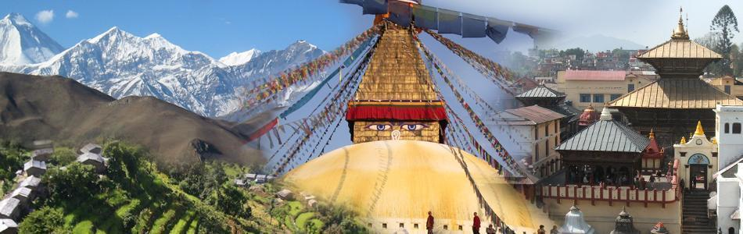

Trip-in-Brief: Kathmandu cultural tours, activities of Mitrata-Nepal Foundation for Children, and a 6-day (4-day trek + 2-day jeep travel) along Pikey Peak trail for a view of 11 Himalayan peaks including Everest, Kanchenjunga, and Manaslu.

The Pikey Peak trek is a hidden gem nestled in the Solu-Khumbu region of Nepal. While it may not be as well-known as the Everest Base Camp or Annapurna Circuit treks, it offers its own unique charm and stunning vistas. One of the distinct features of the Pikey Peak trek is its cultural richness. The trail takes you through traditional Sherpa villages. Along the route, you’ll encounter colorful prayer flags, intricately designed monasteries, and stone Chortens that reflect the region’s Buddhist heritage. Aside from the awe-inspiring mountain vistas and cultural encounters, the Pikey Peak trek also offers a chance to explore the pristine beauty of the Himalayan landscapes.

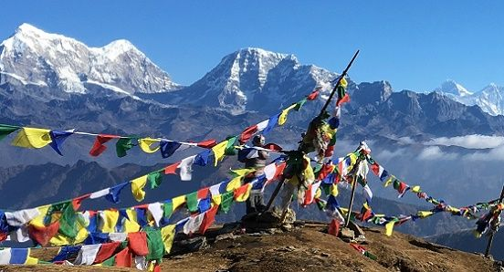

Difficulty: The Pikey Peak trek is considered moderately challenging, making it suitable for trekkers with a moderate level of fitness and some prior trekking experience. Understanding the difficulty level of the trek is crucial for proper preparation.

See below for further information.

Day  Fri  Sat | Date  Nov 1-2 | ITINERARY – OUTLINE  FLIGHT DEPARTING locally Friday evening, Nov. 1, and international flight departing morning, Nov. 2, arriving morning Kathmandu, Nov. 3 | Accommodation  Bed & Breakfast
Sun | Nov 3 | ARRIVE KATHMANDU – airport arrivals: pickup and greet - transfer to hotel. Relax & recuperate in the hotel and see the Thamel area –Late afternoon and evening dinner with the sponsored children of trip sponsors. | Mandala Boutique Hotel
Mon | Nov 4 | KATHMANDU – Daytime: Daytime: Explore Durbar Square (optional): order Nepali hand-made clothing for graduation: late afternoon and evening preparation for the trip to Pokhara.  Late afternoon and evening preparation for trek/trip | Mandala Boutique  Hotel
Tue | Nov 5 | Drive from KATHMANDU TO DHAP BAZAAR (9350 ft.) 7-8 hours, 155 miles by private vehicle (Jeep)  We will leave Kathmandu in our private vehicle to Dhap Bazaar. The path follows the Sunkoshi River, which joins the Tama Koshi River further ahead on our drive, following the large Koshi River until reaching Ghurmi. We will enjoy typical Nepali food and continue our drive along the dense rhododendron forests. We will pass numerous settlement areas before reaching Dhap Bazaar, which will take approximately 7 to 8 hours. Overnight at a lodge in Dahp Bazaar. | Trekking Lodge
Wed | Nov 6 | Trek from DHAP BAZAAR TO JHAPRE (9580 ft.) 4-5 hours, 8 miles  Today, we will continue along a dusty road leading us to Sigane. Again, the trail continues along the bumpy roads to Jhapre. It is famous for exceptional vantage points to the mountains in the country's northern region. We can see Everest (8848m) and the Numbur Himal from here, and we will also visit gompas and stupas in the village. Overnight at a lodge in Jhapre. | Trekking Lodge
Thu | Nov 7 | Trek from JHAPRE TO PIKEY BASE CAMP (11942 ft.) 6-7 hours, 9.3 miles  We will wake up in the early morning to view the first golden rays of the sun falling on the silver lining of snow-capped mountains. Relishing the view, we will continue our trek along a dusty road for some time and then start walking uphill until reaching Bhulbule. From here, the trail becomes steep and ascends through the rhododendron forests and small settlement areas of Lhamuje. The trail beyond Lhamuje opens to reveal a pasture where we can see grazing yaks. We will cross a long Mani wall and climb along the winding road to Pikey Base Camp. We will visit the Yak Cheese Factory and enjoy the magnificent views of the majestic mountains surrounding the valley. Overnight at a lodge in Pikey Base Camp. | Trekking Lodge
Fri | Nov 8 | Trek from PIKEY BASE CAMP - PIKEY PEAK (13336 ft.) and then to JUNBESI (8792 ft.) 6-7 hours, 13.6 miles  The day begins with an early morning trek along the steep rocky ridgeline to the Pikey Peak (4065m). We can marvel at the gorgeous sunrise view over the mountains like Mt. Everest (8848m), Number Chuli (6959m), Thamserku (6608m), Kangtega (6685m), Khatang (6853m), Kanchenjunga (8586m), Manaslu (8163m), Dhaulagiri (8167m), Gaurishankar (7134m), Dorje Lakpa (6966m) and Langtang. Capturing the beautiful views in our cameras, we will descend to Junbesi, followed by the descent to Lamjura. Crossing many Mani walls and Chortens, we will reach Junbesi. We will visit an old monastery in this village and enjoy the beautiful view of Numbur Himal in the North. Overnight at a lodge in Junbesi. | Trekking Lodge
Sat | Nov 9 | Exploration trip/walk to THUPTENCHHOLING GOMPA (9580 ft.) 3-4 hours, then drive from Junbesi to Phaplu (7808 ft.) 2 hours  The day begins with an exploration of the village. We will hike to the Thuptenchholing Gompa, which was founded in the 19th century. The trail ascends uphill along the Junbesi Khola to the Gompa. The Gompa offers in-depth insights into the culture and religious heritage of the region. After some time here, we return to Junbesi and a short local drive to Phaplu (about 2hrs). Overnight at a lodge in Phaplu. | Trekking Lodge
Sun | Nov 10 | Drive from PHAPLU TO KATHMANDU 8-9 hours by private vehicle (Jeep)  In the morning, after breakfast, we will drive back to Kathmandu by our private vehicle, which takes about 8-9 hours, and transfers you to the hotel. evening free time | Mandala Boutique Hotel
Mon | Nov 11 | KATHMANDU – Daytime: Visit children’s elementary schools, BSF office and meet some older children; Afternoon/evening: Enjoy Nepali Dinner cooked by Leena & staff at the Office w/some children. | Mandala Boutique Hotel
Tue | Nov 12 | KATHMANDU – Daytime: Visit Contact Center: eat lunch there and learn about our early childhood center program, meet the teachers and staff, visit some local children’s homes; evening free time | Mandala Boutique Hotel
Wed | Nov 13 | KATHMANDU – Morning: Cultural tour Patan, Shakyamuni Jewelry shopping, visit the Girls hostel Good Shephard in Patan for lunch and afternoon; evening free time | Mandala Boutique Hotel
Thu | Nov 14 | KATHMANDU – Morning: Visit 2nd Contact Center and Swyambhunath; Afternoon/Evening Visit Mangalman’s Singing Bowl Workshop. | Mandala Boutique Hotel
Fri | Nov 15 | KATHMANDU – Daytime: Packing /getting ready for graduation/meeting sponsored children who are available evening free time | Mandala Boutique Hotel
Sat | Nov 16 | KATHMANDU – Daytime: Mitrata Graduation program 2024, including Breakfast and Lunch; Evening: Leave international flight departing late Saturday night
Sun | Nov 17 | Airline Travel, arrival late Sunday night
TRIP INCLUDES:

*All trekking lodges are shared rooms
- All ground transfers with a private van.
- Local guide during the tour days in Kathmandu.
- Accommodation with daily breakfast in Kathmandu Hotel.
- Accommodation with all meals in trekking lodges.
- Private guide and porters along Pikey Peak Trek.
- Private transportation for the drive.
- Temple and old palace entrance tickets/fees during your tour in Kathmandu Valley.

THE TRIP COSTS EXCLUDE THE FOLLOWING:

- Meals (lunch/dinner) in Kathmandu.
- Drinks/bar bills, optional activities (Everest Flight, etc.), and extra transport fees (outside of tour days).
- Accommodations/meals sightseeing in other transit areas.
- International flight from US Home City to Kathmandu.

Pikey Peak Trek Difficulty

Here are some factors to consider:
Jeep Ride:
Travelers will take a private jeep from Kathmandu to Dhap Bazaar roundtrip, traveling 7-9 hours each leg. The first few hours of the journey follow a reasonably comfortable highway (by Nepal standards) built with help from the Japanese. Much of the journey follows the Sun Kosi River, a major river in eastern Nepal popular with rafting groups. Once we reach the town of Okhaldhunga, the road climbs steadily up to Dhap for about three hours. The condition of the road is fair. Travelers should be aware if they are prone to motion sickness.
Altitude:
One of the primary challenges of the Pikey Peak trek is the altitude. The trek reaches an elevation of 4,065 meters (13,336 feet) at Pikey Peak. As you ascend to higher altitudes, the air becomes thinner, making it harder for your body to get the oxygen it needs.

Terrain:
The terrain on the Pikey Peak trek varies from well-defined paths to rocky and uneven trails. You’ll encounter ascents and descents, including some steep sections. The trails can be muddy, slippery, and covered in snow. Trekking poles can be helpful for stability and reducing strain on your knees and legs.

Weather Conditions:
The weather in the Himalayas can be unpredictable, even during the peak trekking seasons. Be prepared for occasional rain, fog, or even snowfall, especially at higher altitudes. Pack appropriate clothing layers to accommodate changing weather conditions and ensure your gear is suitable for cold temperatures.

Duration and Daily Walking Distance:
You’ll be walking for several hours each day, with average daily distances ranging from 8 to 13.6 miles. It’s essential to be physically prepared for sustained walking and build endurance through regular exercises, such as hiking, jogging, or stair climbing.
Daily Weight: Travelers will carry a day pack weighing 10-15 pounds of daily essentials. A porter will carry the remainder of your items, at most an additional 15 pounds. Travelers will receive a recommended packing list.

Remote Areas and Limited Facilities:
Certain sections of the Pikey Peak trek pass through remote areas with limited facilities. Accommodations may be basic teahouses with shared facilities, and food options can be limited to locally available meals in teahouses. Be prepared for the absence of amenities like hot showers and Wi-Fi. Bottled water, additional snacks, and tea, coffee, and soda will be available for purchase.
Spending Money:
Travelers should carry 1000 to 2000 Npr daily for additional beverages/snacks and souvenirs. The exchange is roughly 130 Npr to $1.00.

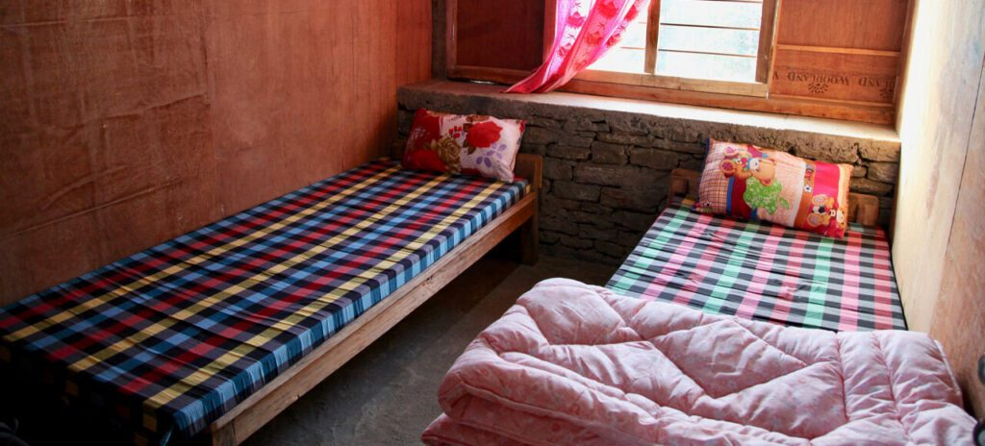
Typical Teahouse shared room.

